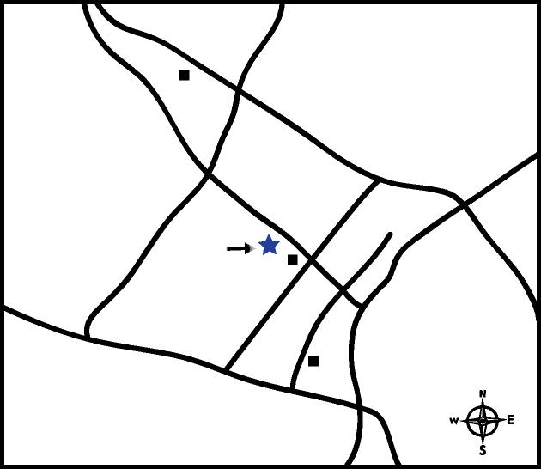
State Hill Road
Route 222
BERKS EYE
TARGET SHOPPING CENTER
BERKSHIRE MALL
Route 422
(Rev. 11/14)
DIRECTIONS

TO: 1802 Paper Mill Road
Wyomissing, PA 19610 Phone: 610-372-0712
FROM THE EAST: (Exeter / Mt. Penn)
Take 422 WEST (West Shore Bypass) making sure to stay on 422 West after passing under Route 12. Take the Paper Mill Road Exit. Proceed straight on Paper Mill Road just past the second traffic light. The office is on the left next to the Hampton Inn.
FROM THE NORTH: (Kutztown / Hamburg / Leesport)
Take 222 SOUTH to the Broadcasting Road Exit. Turn right on Broadcasting Road and proceed to second traffic light at Paper mill Road. Turn left onto Paper Mill Road. The office is on the right before reaching the Hampton Inn.
FROM THE SOUTH & WEST: (Wernersville / Shillington / Ephrata)
Take 222 North to the Crossing Drive / Paper Mill Road Exit. Turn left at stop sign and go to the first traffic light (Woodland Road). Turn left onto Woodland Road and proceed to first traffic light (Paper Mill Road). Turn right onto Paper Mill Road. Our office is located on the left just beyond the first traffic light, next to the Hampton Inn.
FROM MORGANTOWN:
Take 176 NORTH to 422 WEST (West Shore Bypass) making sure to stay on 422 West after passing under Route 12. Take the Paper Mill Road Exit. Proceed straight on Paper Mill Road just past the second traffic light. The office is on the left next to the Hampton Inn.
Woodland
Rd.
Berkshire Blvd
Broadcasting Road
HAMPTON INN
Route 222
Papermill Road

